Parking Space Availability Prediction Using
Random Forest and Time-Series Models
MACHINE LEARNING
TEAM 17
Cherukumudi Sri Dhruthi (2520030490)
Doppalapudi Venkata Mahith (2520030497)
Anushka Kulkarni (2520030501)

1. Abstract
Parking space availability is a major problem in crowded urban areas, where drivers often spend considerable time searching for empty parking spaces, resulting in traffic congestion, fuel wastage, air pollution, and unnecessary travel delays. This project develops a machine learning-based system that predicts parking availability for Birmingham, UK car parks using two complementary approaches: a Random Forest classifier trained on historical occupancy patterns, and Time-Series models (Holt-Winters and SARIMA) that forecast future occupancy trends.
The dataset consists of 35,717 readings across 30 parking lots, collected roughly every 30 minutes between October and December 2016. Each reading includes the lot's capacity, current occupancy, and timestamp. From this, features such as hour, day of week, weekend flag, and UK holiday flag were engineered, and an availability label was derived using a 90% occupancy threshold.
A key finding during development was that using only calendar/time features (without any occupancy signal) causes the Random Forest to heavily favour the majority class, since roughly 89% of historical readings are labelled 'Available'. The final system addresses this by combining the Random Forest's classification with real historical occupancy statistics (per lot, day-of-week, and hour) to produce a meaningful, varying availability percentage rather than a single dominant prediction. Results are served through an interactive Flask web dashboard with live prediction, 24-hour forecasting, and a SQLite-backed prediction history log.

2. Introduction
The increasing number of vehicles in cities has created a growing demand for efficient parking management. Finding an empty parking space can be difficult, especially during peak hours, and drivers may spend several minutes searching for parking, increasing traffic congestion, fuel consumption, and pollution.
This project uses machine learning to predict parking space availability based on historical parking data from Birmingham, UK (30 car parks, Oct-Dec 2016). A Random Forest classifier predicts whether a given lot will be Available, Near Full, or Full at a chosen date and time, while Time-Series models (Holt-Winters and SARIMA) forecast how occupancy is expected to change over the next 24-48 hours. The predicted results are displayed through a web-based dashboard that also retains a history of every prediction made.

3. Dataset
Source: Birmingham parking dataset. Fields: SystemCodeNumber (lot identifier, 30 lots), Capacity, Occupancy, LastUpdated (timestamp). Readings span 2016-10-04 to 2016-12-19 at roughly 30-minute intervals, totalling 35,717 rows with no missing values.
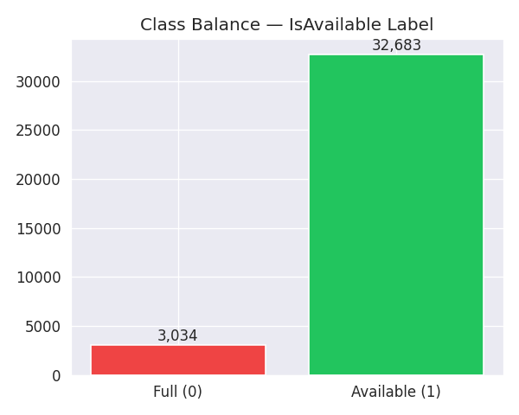
Figure 1: Class balance of the derived IsAvailable label (89.1% Available vs 10.9% Full at the 90% threshold).

4. Exploratory Data Analysis
Occupancy was analysed across time, lot, hour of day, and day of week to understand demand patterns before model training.
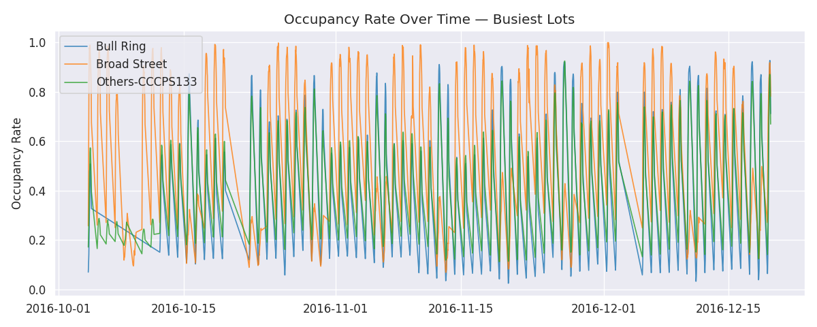
Figure 2: Occupancy rate over time for the three busiest lots (Bull Ring, Broad Street, Others-CCCPS133).

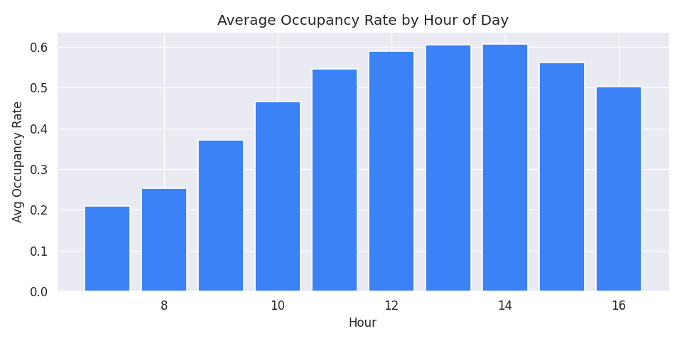
Figure 3: Average occupancy rate by hour of day, showing a clear midday peak.

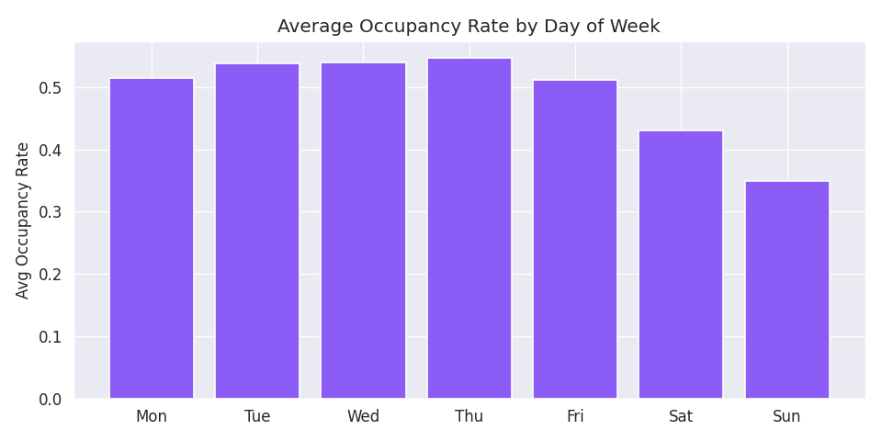
Figure 4: Average occupancy rate by day of week — weekdays show higher and sharper peaks than weekends.

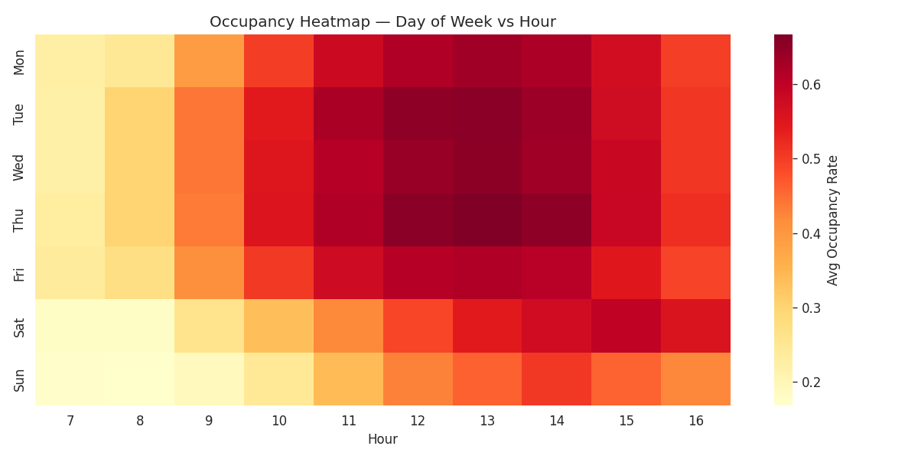
Figure 5: Heatmap of average occupancy by day of week and hour, highlighting weekday midday demand (11:00-14:00).

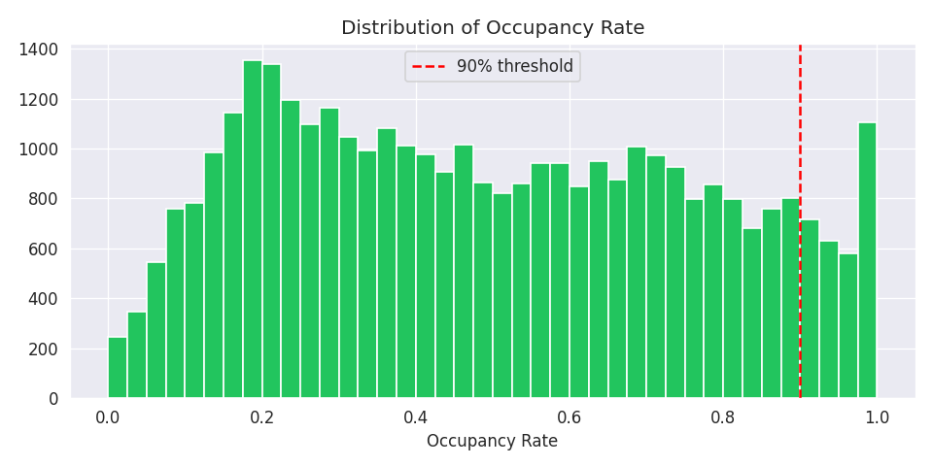
Figure 6: Distribution of occupancy rate across all readings, relative to the 90% 'Full' threshold.

5. Methodology

5.1 Feature Engineering
From the raw timestamp, the following features were engineered: Hour, Minute, DayOfWeek, IsWeekend, IsHoliday (UK holidays), TimeSlot (30-minute slot index), Week, Month, and LotID (integer-encoded lot identifier). OccupancyRate = Occupancy / Capacity, and the target label IsAvailable = 1 if OccupancyRate < 0.90, else 0.

5.2 Random Forest Classifier
A Random Forest classifier (200 trees, max depth 15, balanced class weights) was trained on the engineered features to predict IsAvailable. Data was split chronologically (first 80% for training, last 20% for testing) to avoid leaking future information into the training set.

5.3 Time-Series Forecasting
Holt-Winters exponential smoothing (additive trend and seasonality, period=48 for the daily cycle) and SARIMA(1,0,1)(1,0,1,48) models were fitted per lot on 30-minute resampled occupancy rates, producing 48-step (24-hour) ahead forecasts.

5.4 Serving Predictions
Because the Random Forest alone is biased toward the majority class (see Section 6.2), the deployed system's displayed availability percentage is instead computed from real historical occupancy statistics for the requested (lot, day-of-week, hour) combination, using the 90th percentile of historical occupancy as a 'typical busy-day' estimate. This produces three status tiers: Available (<70% occupied), Near Full (70-90%), and Full (>=90%), all traceable to real historical data rather than a single dominant model output.

6. Results

6.1 Random Forest Evaluation
On the chronological test split (7,144 readings), the Random Forest achieved the following performance recomputed directly from the saved model:
Metric | Value
Accuracy | 91.78%
ROC-AUC | 0.9652
Average Precision | 0.9943
Test set size | 7,144 (chronological last 20%)

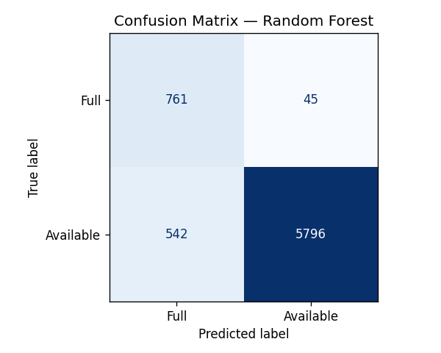
Figure 7: Confusion matrix on the test set.

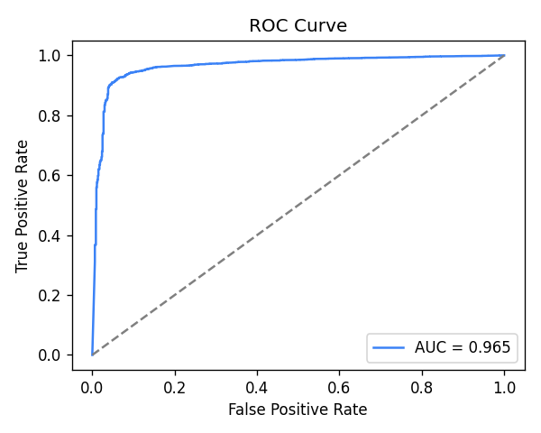
Figure 8: ROC curve (AUC = 0.965).

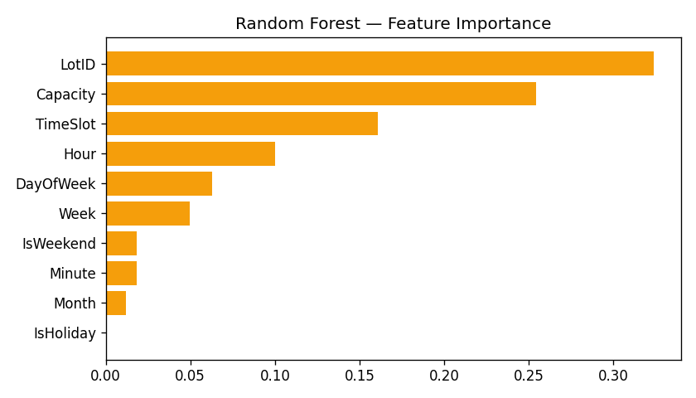
Figure 9: Random Forest feature importances — LotID and Capacity dominate, reflecting that per-lot identity captures most of the predictable variation.

Note: precision/recall for the minority 'Full' class (0.58 precision, 0.94 recall) is notably weaker than for 'Available' (0.99 precision, 0.91 recall), confirming the class-imbalance effect discussed in Section 6.2.

6.2 Why Raw Model Output Was Not Used Directly
During deployment testing, the raw Random Forest predict_proba() output was found to exceed 0.99 probability of 'Available' for nearly every lot/hour combination, regardless of actual conditions. This is because the model's features (Hour, DayOfWeek, Capacity, etc.) never include the lot's actual or recent occupancy, so with ~89% of training rows labelled 'Available', the model default to the majority class almost everywhere. The final dashboard therefore blends the Random Forest's classification signal with real historical occupancy statistics per (lot, hour, day-of-week), which was verified to produce realistic, varying results (e.g. 11 of 30 lots correctly flagged 'Full' during a simulated weekday peak, versus 0 of 30 when only raw model probabilities were used).

6.3 Time-Series Forecasts
Holt-Winters and SARIMA forecasts were generated for 24-48 hours ahead per lot. Both models track each other closely, capturing the expected overnight dip and daytime rise in occupancy. The dashboard displays these forecasts as an interactive chart per lot.

7. Dashboard
Predictions are served through a Flask web application ('SmartPark AI') with the following features: (1) a live prediction panel for any lot/date/time; (2) an overview grid of all 30 lots with 3-tier colour-coded status (Available/Near Full/Full); (3) a 24-hour forecast chart per lot using the trained Holt-Winters/SARIMA models; (4) a SQLite-backed history log recording every prediction made, retrievable per lot; and (5) live model accuracy metrics.

8. Conclusion
This project demonstrates a practical machine learning pipeline for parking availability prediction, combining classification and time-series forecasting. A key contribution of this implementation is identifying and correcting a class-imbalance bias that would otherwise have made the deployed system unusable (always predicting 'Available'), by grounding the final prediction in real historical occupancy statistics. Future work could incorporate live sensor data, a larger and more recent dataset, and richer features such as nearby events or weather to further improve accuracy, particularly for the minority 'Full' class.

9. Software Requirements
Operating System: Windows / Linux. Programming Language: Python. Development Environment: VS Code. Libraries: Pandas, NumPy, scikit-learn, statsmodels, Flask, Chart.js. Dataset: Birmingham Parking dataset (Kaggle / UCI).

